6.1 - Greatest Common Factor and Factor by Grouping

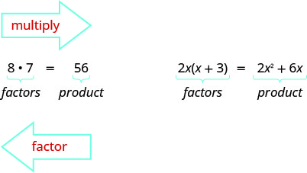
The greatest common factor (GCF) of two or more expressions is the largest expression that is a factor of all the expressions.

Find the greatest common factor (GCF) of two expressions.
Step 1. Factor each coefficient into primes. Write all variables with exponents in expanded form.
Step 2. List all factors, use exponential notation
Step 3. Bring down the common factors that all expressions share (take the smallest exponent)
Step 4. Multiply the factors.

Find the greatest common factor of 21x³y⁵, 9x²y², 15xy⁴

Find the greatest common factor: 25m⁴,35m³,20m²

Find the greatest common factor: 14x³,70x²,105x
Factor the GCF from a polynomial
1. Find the GCF of the terms
2. Use the distributive property ab+ac=a(b+c), where a is the GCF

Factor: 8m³−12m²n+20mn²

Factor: 9xy²+6x²y²+21y³

Factor: 3p³−6p²q+9pq³

Factor: 5x³−25x²

Factor: 2x³+12x²

When the leading coefficient is negative, we factor the negative out as part of the GCF.

Factor: −4a³+36a²−8a

Factor: −4b³+16b²−8b

So far our greatest common factors have been monomials. In the next example, the greatest common factor is a binomial.

Factor: 3y(y+7)−4(y+7).

Factor: 4m(m+3)−7(m+3)

Factor: 8n(n−4)+5(n−4).

Factor by grouping
Factor by grouping: xy+3y+2x+6

Factor by grouping: xy+8y+3x+24

Factor by grouping: x²+3x−2x−6

Factor by grouping: 6x²−3x−4x+2

Factor by grouping: x²⁻⁵x+2x−10

Factor by grouping: 20x²−16x−15x+12
Section 6.2: Factor Trinomials

Factor Trinomials of the Form x²+bx+c

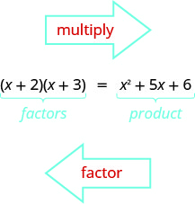
How do the numbers 5 and 6 on the right relate to the 2 and 3 on the left?

Factor: x²+11x+24

Factor: q²+10q+24

Factor: t²+14t+24
Factor: y²−11y+28

Factor: u²−9u+18

